PROJECT REPORT

MESS CROWD PREDICTOR
(https://github.com/nush08-ma/Mess-Predictor.git)

FUNDAMENTALS IN AI AND ML (CSA2001)

BY ANUSHKA MATHUR (25BCE10039)

PRADEEP KUMAR MISHRA -FACULTY



PROJECT OVERVIEW :
The Smart Mess Predictor is a helpful tool made to tell students how long they might have to wait for food at the college mess. It uses a "Smart" system (Machine Learning) to look at past data and guess future wait times.

PROBLEM STATEMENT :
Students at campus often don't know how busy the mess will be. The wait time changes based on:
- Who is cooking: Some caterers are faster than others.
- The time: Lunch and dinner times are usually much busier.
- What is on the menu: Popular dishes like Biryani cause much longer lines than simple dishes like Khichdi.

REQUIREMENTS :
FUNCTIONAL:
Give Predictions: Tell the user exactly how many minutes they will likely wait.
Show Menu Options: Let users pick their mess and see what food is available.
Learn from Students: Allow students to type in their real wait time so the AI gets smarter.
Show Graphs: Display pictures of trends so students can see the best time to eat.
NON FUNCTIONAL :
Easy to use: The design must work well on phones.
Fast: It should give an answer immediately.
Smart: It should use a special "Gradient Boosting" math model to be as accurate as possible.

SYSTEM ARCHITECTURE :
The app is built as an "all-in-one" file that handles everything:
- Backend: Uses Python and Flask to manage the data and the AI.
- The Memory (Database): Uses SQLite to remember old wait times.
- The Look (Frontend): A modern website style using HTML and CSS.
- The Math (ML): Uses Scikit-learn to spot patterns in the data.

FEATURES :
Live AI Prediction: Estimates wait times using a 15% confidence range (showing "Best Case" and "Worst Case").
Trend Charts: Uses Chart.js to show if the line is getting longer or shorter.
Popularity Tags: Automatically labels dishes as "Popular" or "Quiet".
Instant Re-training: When a student submits a new wait time, the AI learns from it right away.

DESIGN DECISIONS AND RATIONALE :
Gradient Boosting: We chose this specific AI model because it is very good at handling different factors like "time" and "food type" at once.
Single-File App: We put the code in one file so it is very easy to set up and run on any computer.
Fallback Logic: If the AI is still "learning," the app uses a simple average so the user always gets an answer.

IMPLEMENTATION DETAILS :
The Data: The system starts with a list of "Sample Data" for caterers like Mayuri, Safal, JB, and AB Catering.
The Training: The code turns words (like "Veg Biryani") into numbers so the computer can understand them.
The API: We created "routes" so the website can talk to the database safely.

RESULTS :
Accurate Predictions: The system correctly shows that popular dishes can take up to 50 minutes, while others take only 10.
Interactive UI: The dark-mode design is easy on the eyes and clearly shows the most important information.

USAGE :
RUN THE CODE :
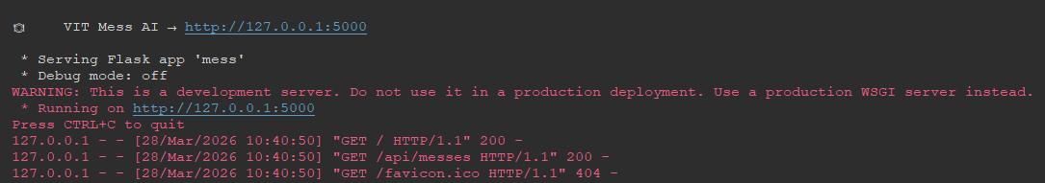
CLICK ON : http://127.0.0.1:5000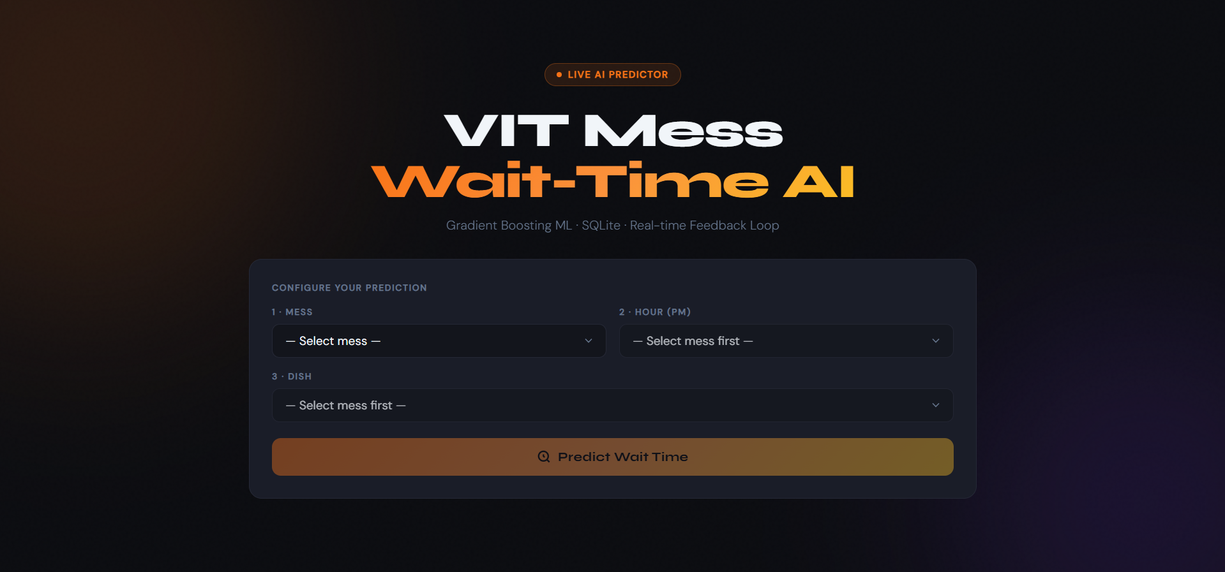
ENTER DETAILS OF YOUR CHOICE :
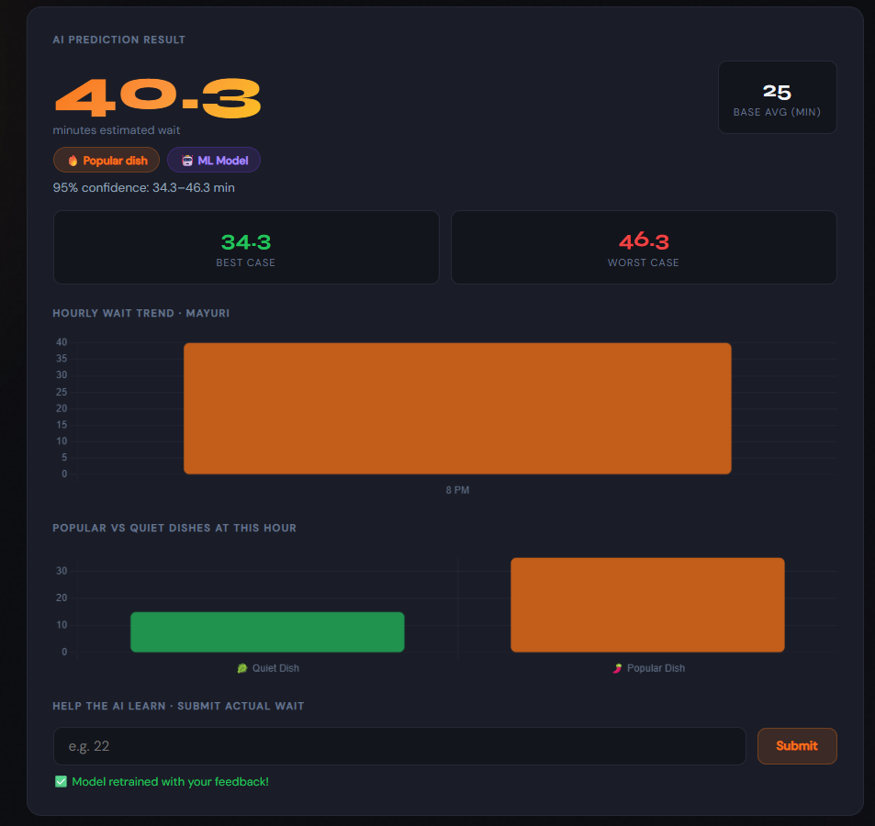

LEARNINGS AND KEY TAKEAWAYS :
Crowdsourcing is Powerful: The more students use the app, the better the AI becomes.
Simple is Better: Using a single-file approach made the project much faster to build.
Visuals Help: Graphs make it much easier for students to understand "Rush Hour" than just looking at numbers.

REPOSITORY LINK :
(https://github.com/nush08-ma/Mess-Predictor.git)

